A+ Computer Science Array of References – MOVING SHAPES Lab Value - 100

Lab Goal : This lab was designed to teach you how to design and use classes, instantiate objects, use graphic methods, and use if statements.

Lab Description : Write a program in to create a unique shape using graphics. Make the shape move around the screen and bounce off of the walls.

Part One :: Use the Shape.java file to create your own shape. Complete the Shape constructor and add code to the draw method to draw your own shape. Use ShapePanel.java and GraphicsRunner.java to test your Shape class.

Part Two :: Use MovingShapePanel.java and GraphicsRunner.java to further test your Shape class. You must get your shape to move around the screen. You will need to add set and get methods to the Shape class for instance variables xPos, yPos, xSpeed, and ySpeed.

Part Three :: Use the MovingShapePanel.java and GraphicsRunner.java to expand the project.
Add in an array of Shapes so that many shapes may appear on the screen.
private Shape[] shapes; //define an instance variable

Instantiate the array in the constructor.
shapes = new Shape[7]; //make this any size you want
Add in Shapes objects to the array and get them to all move around the screen.
shapes[0] = new Shape(~~~~~~~);

Part One :
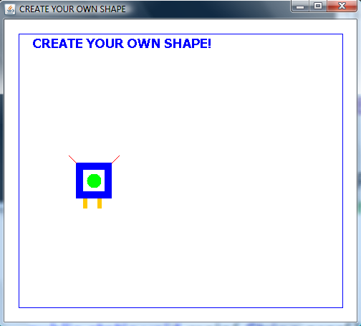
Files Needed ::
Shape.java
ShapePanel.java
MovingShapePanel.java
GraphicsRunner.java

The shapes do not move in part one.

Part Two :
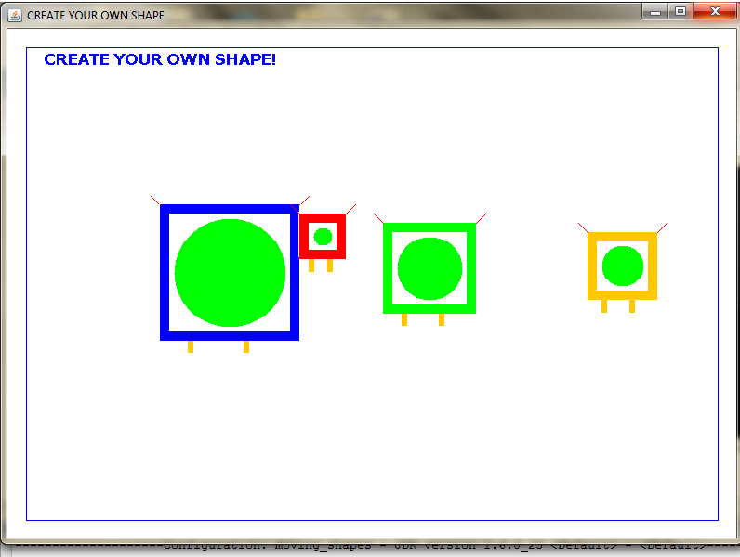
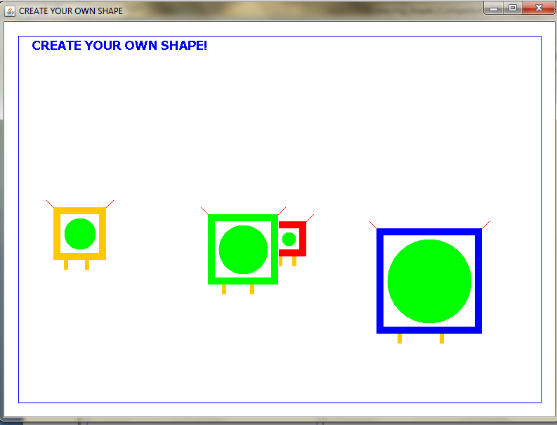
The shapes move around the screen and bounce off the walls in part two.

